Broadcasting in Python

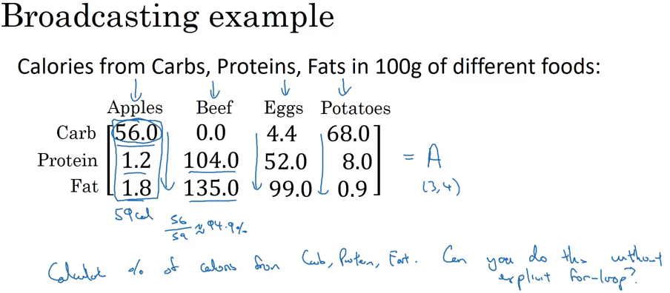

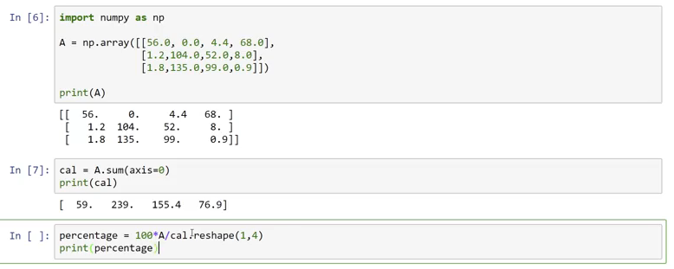



Axis = 0 means sum vertically

Axis = 1 mean sums horizontally

The reshape command is a little redundant here because ‘cal’ is already a 1x4 matrix.

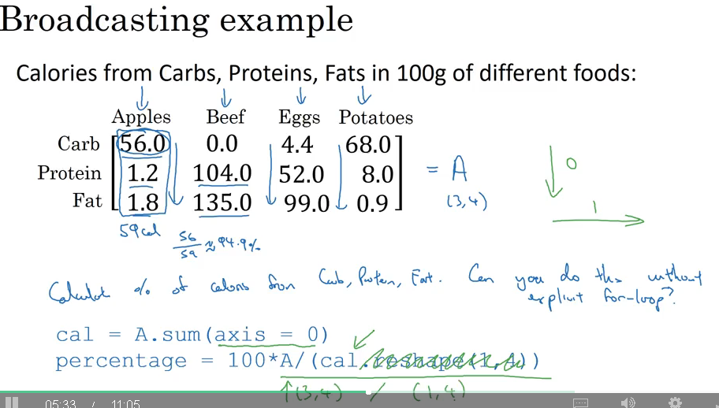

How can you divide a (3,4) matrix by a (1,4) matrix

Python broadcasts the constants and adds them to every element in the matrix.

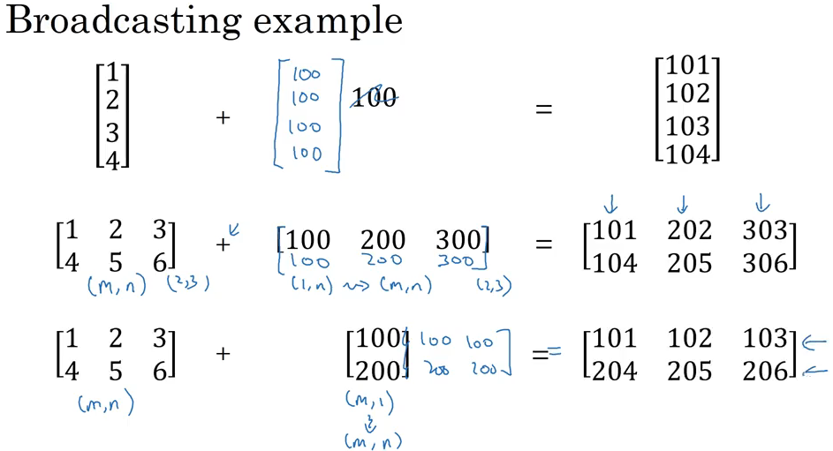

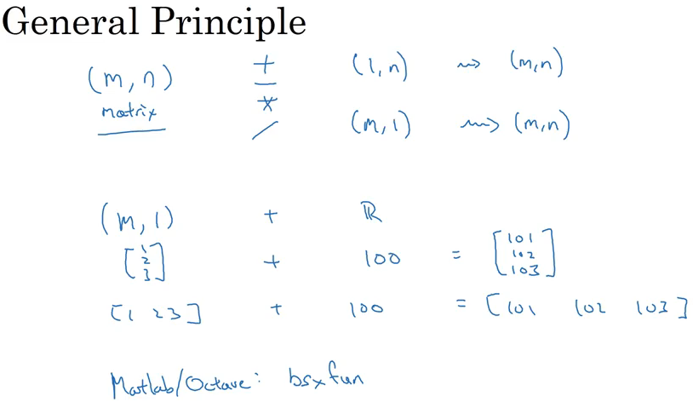

Which of the following numpy line of code would sum the values in a matrix A vertically?

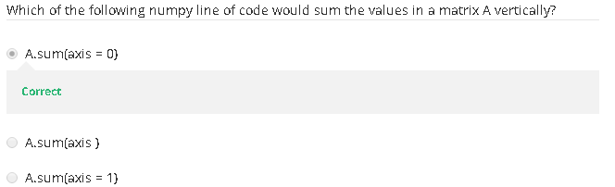

**A Note on Python / Numpy Vectors**

With broadcasting the code is very flexible but it can also call some bugs because of the nature of the language.

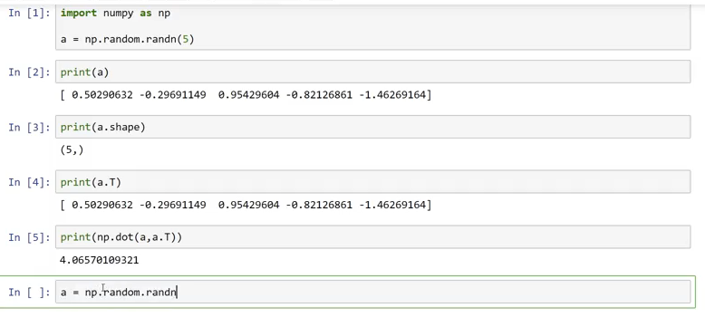

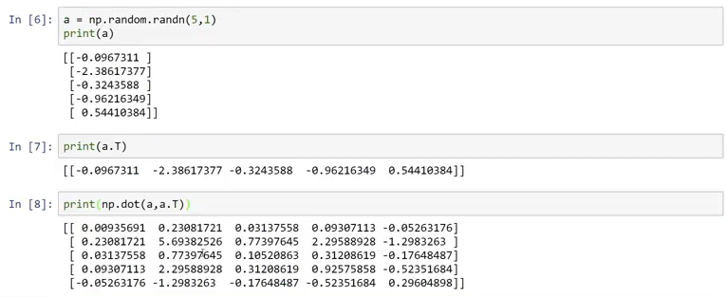

Here the main different between the two arrays is that we originally defined it neither as a column or row array because we left it blank a=np.random.rand(5) it should have been a=np.random.rand(5,1).

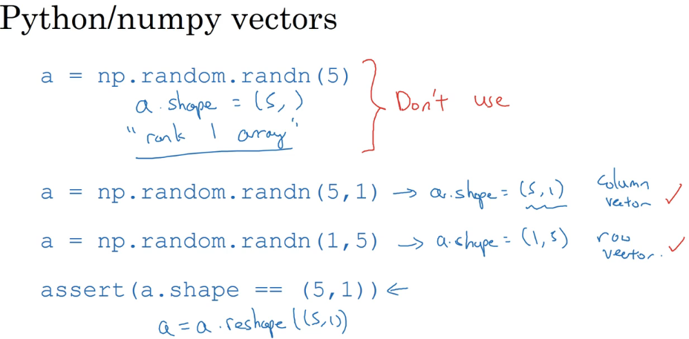

Don’t be shy about using the reshape function.

What kind of array has dimensions in this format; (10,)?

